Project Report
SCRIBBLE TO DIGITAL
Project Documentation
College code: 0110
COLLEGE: Dharmamurthi Rao Bahadur Calavala Cunnan Chetty’s Hindu college
TEAM ID: SWTID-2026-6795
TEAM MEMBERS:
- Team Leader: KARTHIKEYAN.V
- TEAM MEMBER 1: DINESHMARAN.K
- TEAM MEMBER 2: NARESHKUMAR.B.S
- TEAM MEMBER 3: THARUNKUMAR.E.S
Project Overview
Scribble to Digital is an Artificial Intelligence based application that converts handwritten notes into structured digital text. The application is developed using Python and Streamlit.
Students and professionals often write notes on paper. However, converting these handwritten notes into digital form manually takes time. This project solves that problem by automatically converting handwritten images into readable digital text.
The system processes handwritten images, extracts text using OCR technology, and displays the digital output through a web interface.
Objective of the Project
The main objectives of the project are:
- Convert handwritten notes into digital text
- Improve readability of handwritten content
- Provide an easy interface to upload images
- Extract text automatically using OCR
- Display structured digital output
This system helps users quickly digitize handwritten notes.
Technologies Used
The following technologies are used in this project:
- Python
Used as the main programming language.
- Streamlit
Used to build the web application interface.
- OpenCV
Used for image processing and enhancement.
- OCR (Optical Character Recognition)
Used to extract text from handwritten images.
- Google Gemini API
Used for improving extracted text and generating clean output.
- VS Code
Used as the development environment for coding.
- GitHub
Used to upload and store the project repository.
System Architecture
The Scribble to Digital system consists of the following modules:
- User Interface (Streamlit)
Allows users to upload handwritten images and view results.
- Image Processing Module (OpenCV)
Enhances the uploaded image by removing noise and improving clarity.
- OCR Module
Extracts text from the processed image.
- AI Processing Module (Gemini)
Improves the extracted text and formats it properly.
- Output Module
Displays the processed results in digital format.
Application Workflow
The workflow of the project is demonstrated in the video as follows.
- Step 1 – Writing the Code
The application code is written in Python using the Streamlit framework. The code includes modules for image upload, image processing, OCR text extraction, and AI text correction.

- Step 2 – Running the Streamlit Application
  - The application is executed using the command:
  - streamlit run app.py
  - This command starts the Streamlit server and creates a local web application.

- Step 3 – Opening the Web Application
- After running the command, the application opens in the browser using the local address:
- http://localhost:8501
- The user interface of the Scribble to Digital application is displayed.

- Step 4 – Uploading Handwritten Image
- The user uploads an image containing handwritten notes using the Browse Files option.
- The uploaded image is displayed on the screen.

- Step 5 – Image Processing
The system processes the uploaded image using image processing techniques such as:
- Grayscale conversion
- Noise removal
- Image enhancement
- The processed image is shown beside the original image.

- Step 6 – OCR Text Extraction
- The OCR engine analyzes the processed image and extracts the handwritten text.
- The extracted text is displayed as Raw OCR Text in the application.

- Step 7 – Digital Output Generation
- The extracted text is processed by the AI model to generate structured digital notes.
- The final output is displayed under Digital Output .

- Step 8 – Uploading Project to GitHub
Finally, the project is uploaded to a GitHub repository. GitHub is used to store the project code and maintain version control.
User Interface Features
The application interface provides the following features:
- Upload handwritten image
- Display uploaded image
- Show processed image
- Display raw OCR text
- Show cleaned digital output
The interface is simple and easy to use.
Testing
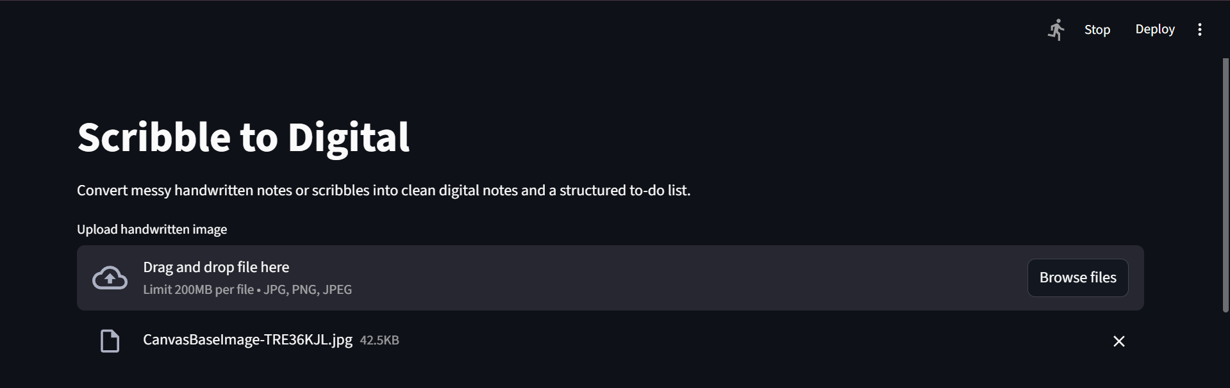
Fig:5.1 Image uploading Interface
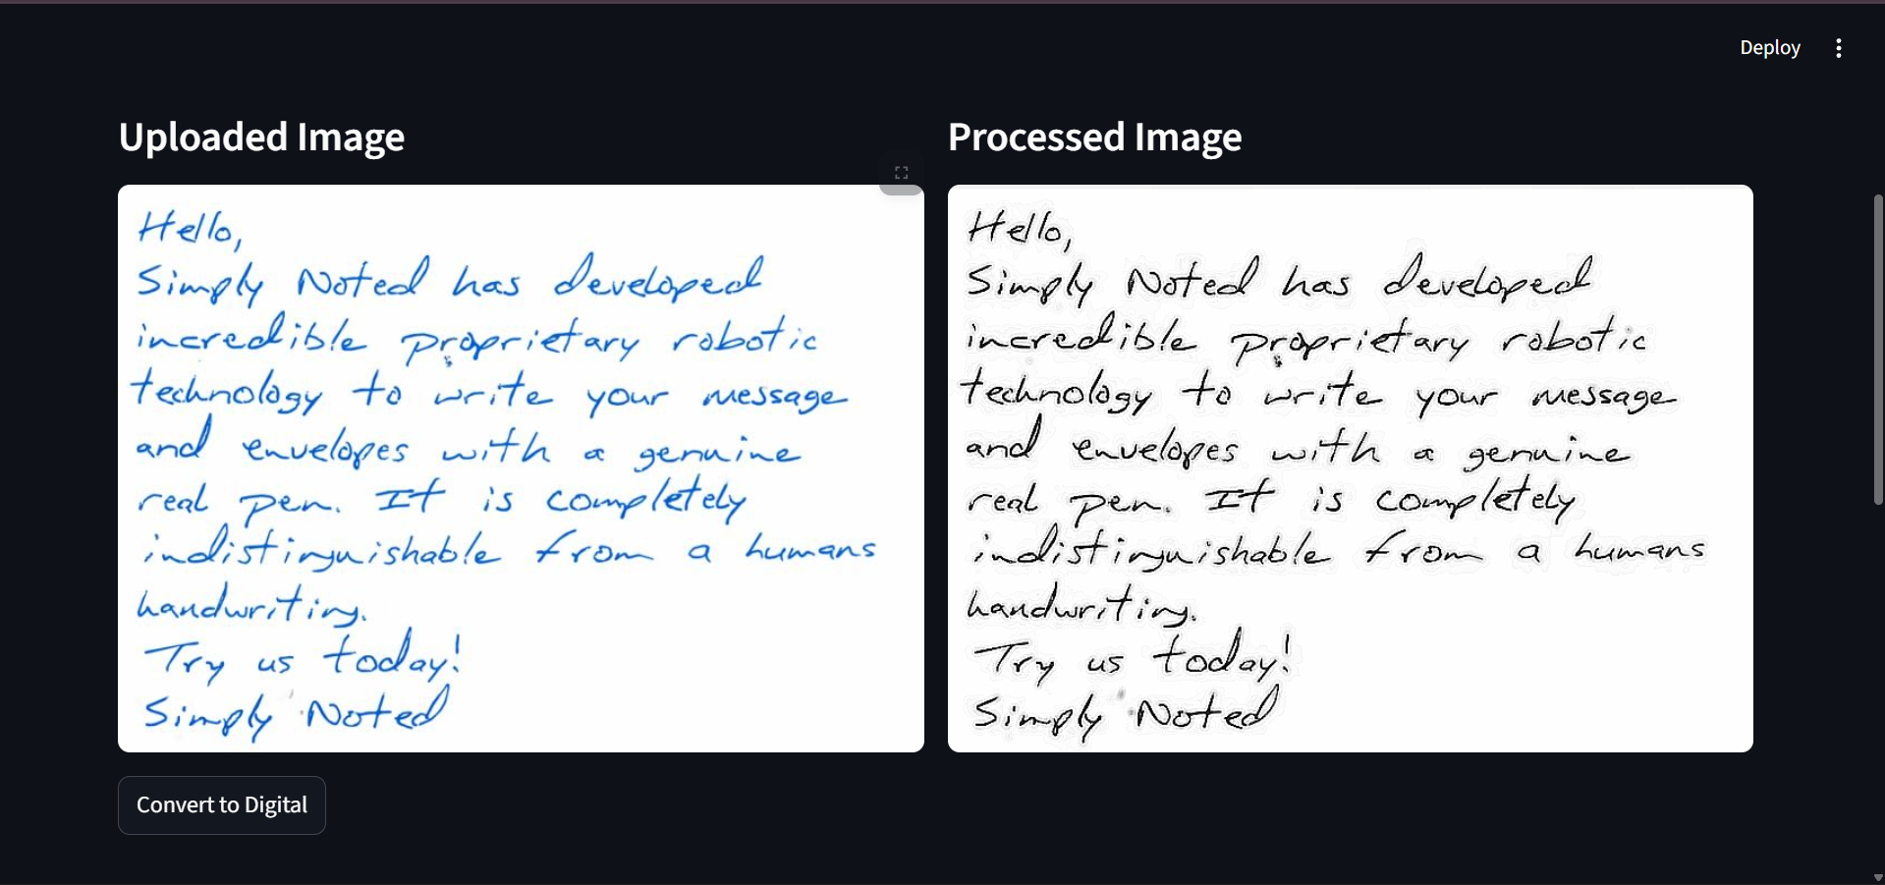
Fig:5.2 Image Processing Using Open Cv
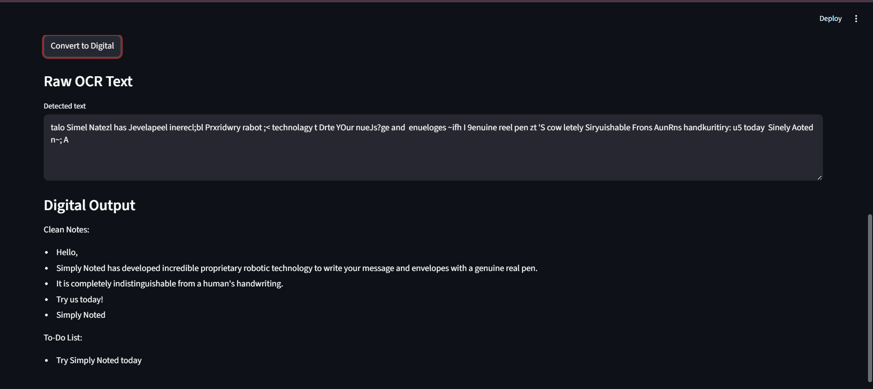
Fig:5.3 Digitized Notes From Image Using Google Genai
The application was tested with different handwritten images to check the accuracy of OCR text extraction and AI correction.
Testing included:
- Clear handwriting
- Medium quality handwriting
- Slightly blurry images
The results showed that the system successfully converts handwritten notes into digital text when the image quality is reasonable.

Advantages
- Saves time in converting handwritten notes
- Easy to use interface
- Automatically extracts text
- Improves readability of notes
- Useful for students and professionals
Conclusion
- The Scribble to Digital project demonstrates how AI and OCR technology can be used to convert handwritten notes into digital format.
- The system provides an efficient way to digitize handwritten content and improve productivity. With the help of Streamlit, OpenCV, and AI models, the application successfully converts handwritten images into structured digital text.

